**Project Development**

**Performance Testing**

|  |  |
| --- | --- |
| Date | 19 November 2022 |
| Team ID | PNT2022TMID12996 |
| Project Name | Project – PLASMA DONOR APPLICATION |
| Maximum Marks | 10 Marks |

**Performance Metrics:**

Performance testing for our hosted website was done using an online tool:

<https://www.webpagetest.org/>

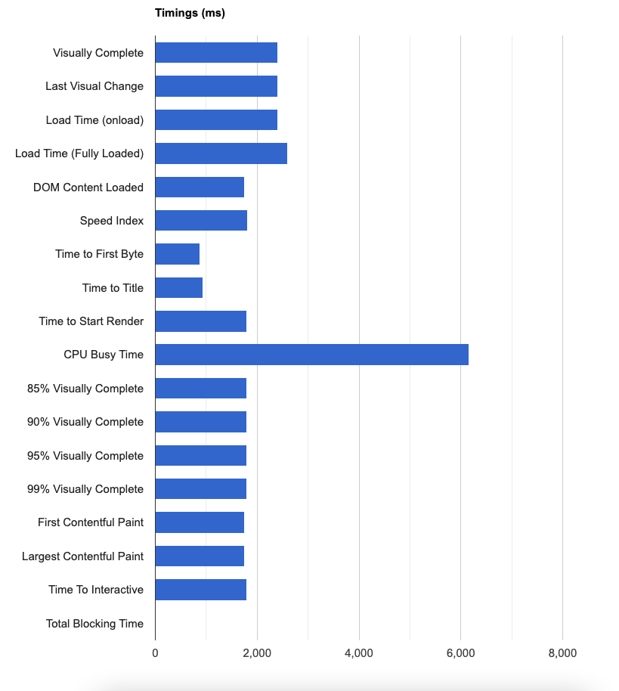

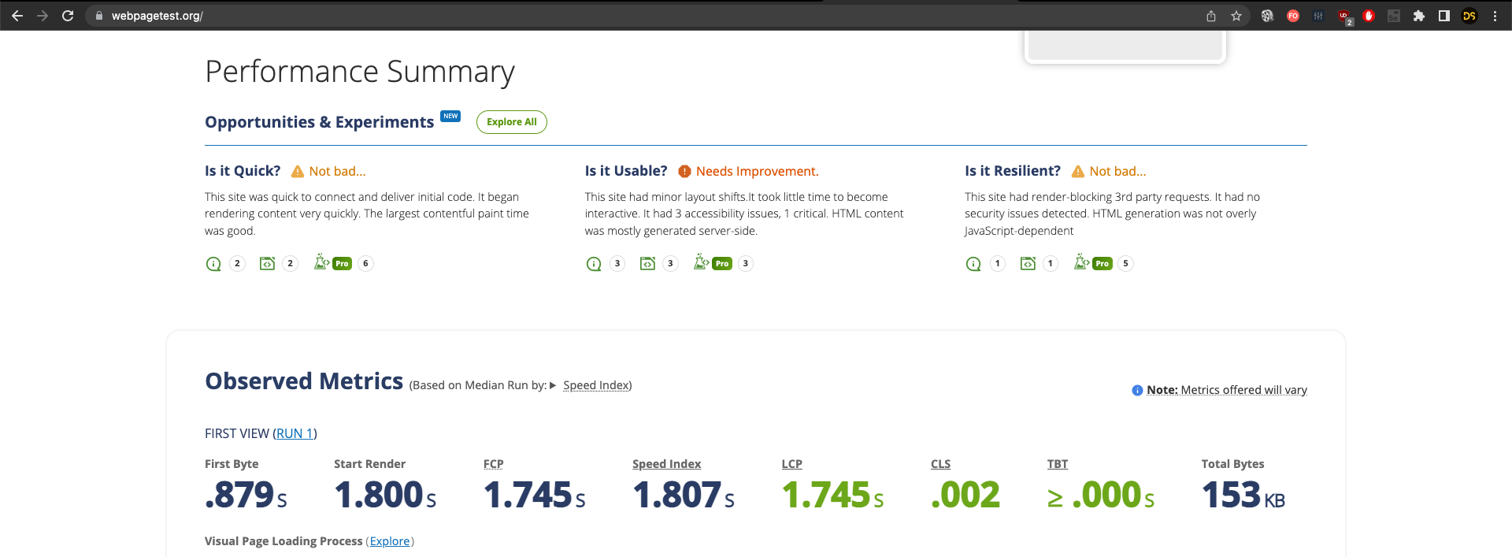

**Test Cases:**

